[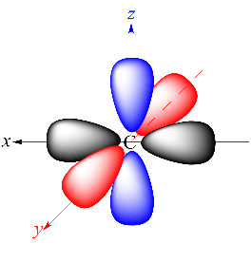](http://www.google.com/url?sa=i&rct=j&q=&esrc=s&source=images&cd=&cad=rja&uact=8&ved=0ahUKEwjet8Pd_LvXAhVBMSYKHU8gCNMQjRwIBw&url=http://www.chem.ucla.edu/harding/IGOC/A/atomic_orbital.html&psig=AOvVaw2pr54scwrdgbYFtxrKhtsP&ust=1510677055472142)

[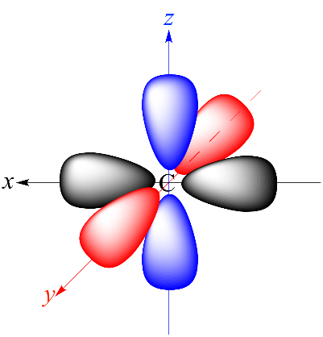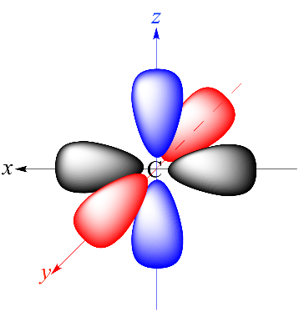](http://www.google.com/url?sa=i&rct=j&q=&esrc=s&source=images&cd=&cad=rja&uact=8&ved=0ahUKEwjet8Pd_LvXAhVBMSYKHU8gCNMQjRwIBw&url=http://www.chem.ucla.edu/harding/IGOC/A/atomic_orbital.html&psig=AOvVaw2pr54scwrdgbYFtxrKhtsP&ust=1510677055472142)

[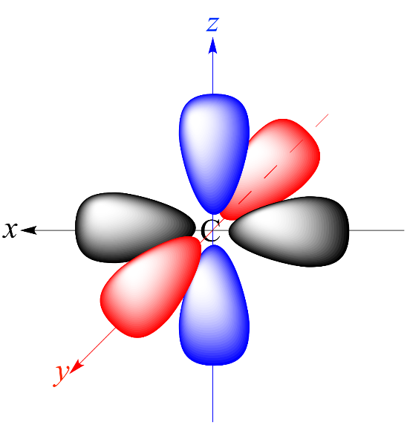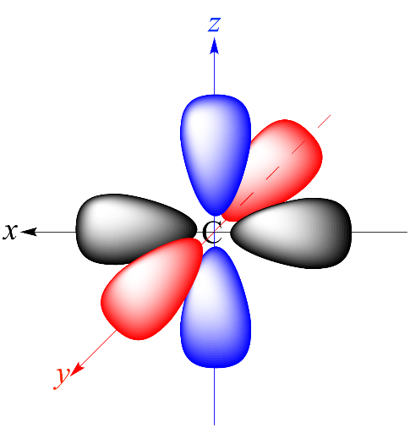](http://www.google.com/url?sa=i&rct=j&q=&esrc=s&source=images&cd=&cad=rja&uact=8&ved=0ahUKEwjet8Pd_LvXAhVBMSYKHU8gCNMQjRwIBw&url=http://www.chem.ucla.edu/harding/IGOC/A/atomic_orbital.html&psig=AOvVaw2pr54scwrdgbYFtxrKhtsP&ust=1510677055472142)

[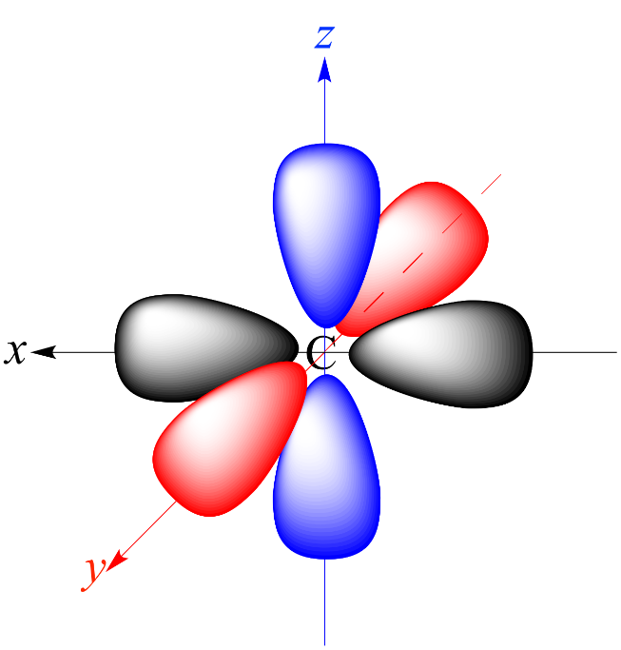](http://www.google.com/url?sa=i&rct=j&q=&esrc=s&source=images&cd=&cad=rja&uact=8&ved=0ahUKEwjet8Pd_LvXAhVBMSYKHU8gCNMQjRwIBw&url=http://www.chem.ucla.edu/harding/IGOC/A/atomic_orbital.html&psig=AOvVaw2pr54scwrdgbYFtxrKhtsP&ust=1510677055472142)

